Self Reflection
Table of Contents
1. Introduction 3
2. Self Introduction 3
3. Employment 3
4. Personality and Learning Style 4
4.1 Big 5 Factor Personality Test 4
4.2 Kolb Learning Style 5
4.3 Procrastination Indicator 6
4.4 Type A and B Personality 6
5. Personal Assessment 6
5.1 Strengths 6
5.2 Weakness 7
6. Critical Incident 7
7. Reflection 8
8. Personal Needs Development 8
9. Plans and Ambitions 9
Bibliography 10
Annexure 11
Appendix 1: The Big 5 Locator 11
Annexure 2: Procrastination Indicator 12
Annexure 3: Type A & B Personality 13

Introduction
This report is an evaluation of my personality using differing models thus identifying my strengths and learning. Further, the report proceeds by determining the scope of learning for me. Findings from both that are experiences and learning assist me in the identification of my personal needs that is to be developed along with the determination of changes in my ambitions if any.

Self Introduction
Being a part of my family business allured me since my childhood and thus assisted me in shaping my career options. For realising my fascination of being a part of the family business I opted for commerce and procured 94% which is considered to be a benchmark in my life. Proceeding further I started with my graduation course where I became familiar with differing aspects of business. But I was continually drawn towards marketing communication owing to the fact that my sister was also excelling in her career by taking up this subject. Thus I have planned to take a full-time course in MA Marketing Communications in London School of Economics. This course will be of significant help as it will allow me to comprehend theoretical soundness related to marketing communications in a business which I can further apply in my family business.

Employment
Presently I am associated with my family business which is an amalgamation of multiple industries mainly operational in textiles and hospitality sectors. I have experiences of working in a hotel which is a part of my family business. Also while pursuing my graduation I was associated with Robin Hood Army which involved in the provision of food for underprivileged children in the slums. Both these experiences have been enriching but yet speaking frankly I have had no formal employment so far.

Personality and Learning Style
Personality is the manifestation of one's behaviour and actions (John et al., 2010). Thus it is mandatory to examine the same so that one can identify his or her strengths and weakness (Major et al., 2006). The ultimate outcome would be the achievement of excellence in one's career and life.

4.1 Big 5 Factor Personality Test
This test assisted me to gauge myself on 5 differing personality traits and thus gain a fair idea about the development that I need to undergo (Lee & Ashton, 2005; Rammstedt & John, 2007). The test marking is provided in annexure 1 and the results in the table below:
Personality Trait | Rows | Score | Interpretation
Level of Openness | 3,8,13,18,23 | 18 | Between Moderator and Explorer
Level of conscientiousness | 5,10,15,20,25 | 14 | Between Flexibility and Balanced
Level of extraversion | 2,7,12,17,22 | 15 | Ambivert
Level of agreeableness | 4,9,14,19,24 | 16 | Between Negotiator and Adapter
Level of negative emotionality | 1,6,11,16,21 | 13 | Between Resilient and Responsive
Table 1 Self Personality Assessment using Big 5 Personality Trait Theory

4.2 Kolb Learning Style
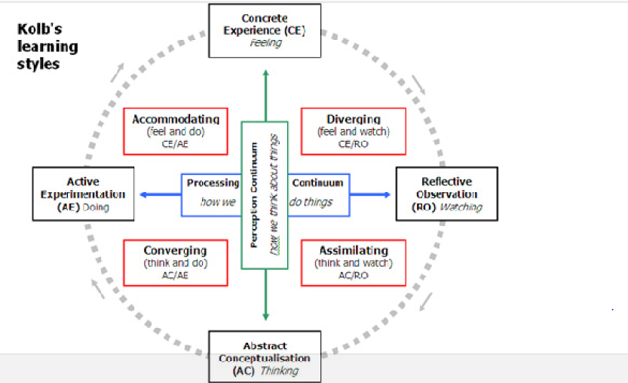
Figure 1 Kolb's Learning Styles
Source: (Clarke & Furnell, 2012)
A person learns from one's experiences which he reflects upon and then conceptualises to experiment the same (Pashler et al., 2008). Based on the above model I rate myself as a Converger as I think and do activities. Given the situation I first prefer to think about the same from differing perspectives and analyse the same. Once I gauge the perspectives and listen to viewpoints of all related to the situation I based on my personal judgment take decisions. I try to strike a balance between abstract conceptualization and active experimentation as seen in figure above.

4.3 Procrastination Indicator
Based on the personality test using this model (refer annexure 2) I scored 3.2 (that is 32 divided by 10). This indicates that I am a in a position to identify varied factors that might force me to delay my tasks and thus take timely actions to control them. I thus categorise myself as a rebel as I have self-control over my environment. I am also determined to complete my tasks in due time irrespective of hurdles faced.

Type A and B Personality
My total score has been 101 based on this test analysis (refer annexure 3) which indicates that I am person with Type B personality. Thus it is an indicator that I am focused and know what to achieve ultimatel (Gledhill, 2007)y. I am calm and composed who is not much affected by competitive pressure an deal with it as a game with a positive spirit.

Personal Assessment
Based on the above analysis using the Big 5 model the findings of my personality are categorised under 2 heads namely strengths and weaknesses.

5.1 Strengths
- I have instincts of being innovative as I can generate novel ideas due to my curiosity to do something new
- I am flexible which mean I am spontaneous and ready for change which is very significant in a dynamic business environment (Crossan et al., 2008)
- I am warm and thus can empathise with others which will make me a good team leader
- Being warm ready makes me altruistic and humble towards others which are again important for a team player (Jenkins, 2014)
- Emotionally I am very strong which implies emotionally stability and security.

5.2 Weakness
- I am not organised which is not acceptable in a business especially in communication division
- I am theoretical and thus can gauge situations based on theories incidents which will not ensure sensible decision making.
- Irrespective of being warm I am an introvert which is a major hindrance while communicating with others (Zafar & Meenakshi, 2012)
- However, I am self-interested which might be an issue when working in teams
It is to overcome these weaknesses and generate a sense of better communication which will help me to become a good team leader as well as a player I decided to take up MA in Marketing Communications.

Critical Incident
One of the most critical incidents which I faced while pursuing this course was to complete a marketing activity. I was in charge of the sales team who were supposed to visit the varied commercial organisations to promote the hotel (a product) and thus motivate them to conduct seminars, conferences etc. with our hotel. This incident was not only important for me academically but also was significant as the product to be promoted was related to my family business which I always aspired to join. Thus this activity provided me with an opportunity to test my skills and then comprehend whether I could be successful in reaching organisational goals of my family business.
During this session, I realised that my interpersonal communication skills were very futile which resulted in the disappointment of my team as well as customers we were supposed to deal with.

Reflection
The course to a larger extent has been successful in developing my communication skills. It is evident from the fact that while experiencing the critical incident outlined above I was able to exhibit the same. My presentation materials were excellently made but I failed to deliver them verbally. So to overcome the scenario I focused more on showing the presentation material thus attracting my target audience towards the same. When the target audiences were engrossed within the materials I quickly read content for what to speak next. I was able to handle situations spontaneously through an innovative approach. During this incident, I realised the importance of being organised also. As all the presentation materials were organised and duly numbered I did not face much problem. I generally do not organise my materials but this incident was an exception and this approach paid off positively. Further, I have been focusing on theoretical aspects imparted through the curriculum. But I realised it is equally important to focus on their practical implementations also through this incident.

Personal Needs Development
In order to develop myself for future and enhance my employability skills, I need to focus on communication skills. In the short run, I would aim at developing my listening skills so that I become a patient listener and comprehend information from people surrounding me. I also aim to develop my patience so that I am more controlled and composed during conversations. This will also prohibit me from asking redundant questions or jump to conclusions based on incomplete information procured.
In the long run, I need to develop team skills wherein I have to gain abilities to communicate effectively with my team members. I also need to develop public speaking skills and those related to negotiations. This will help me to deal with the customers more effectively and thus have a positive impact on our family business sales and marketing. Effective negotiation skills will also help me deal with organisational employees in a better way.

Plans and Ambitions
I have felt positive changes within me as a result of this course. I am satisfied with my decision of opting for this course as I have learned a lot. Today I feel more confident and have developed a positive attitude to while communicating. I have developed abilities to listen to others and then develop my opinion. Even my decisions are taken based upon my theoretical as well as practical knowledge thus making them more effective. I plan to complete this course of my successfully and join my family business to exhibit my learning for mutual benefits.
I plan that the short run needs would be achieved within a period of 6 months to 1 year whereas the long run needs would be achieved within a period of 1-2 years.

Bibliography
Clarke, N., & Furnell, S. (2012). Proceedings of the Sixth International Symposium on Human Aspects of Information Security & Assurance (HAISA 2012). London: Lulu.com.
Crossan, M., Vera, D., & Nanjad, L. (2008). Transcendent leadership: Strategic leadership in dynamic environments. The leadership quarterly , 19 (5), 569-581.
Gledhill, A. (2007). BTEC National Sport and Exercise Science Student Book (2nd Ed.). Oxford: Heinemann.
Jenkins, S. (2014). John R. Wooden, Stephen R. Covey and Servant Leadership. International Journal of Sports Science & Coaching , 9 (1), 1-24.
John, O., Robins, R., & Pervin, L. (2010). Handbook of Personality: Theory and Research (3rd Ed.). New York: Guilford Press.
Lee, K., & Ashton, M. (2005). Psychopathy, Machiavellianism, and narcissism in the Five-Factor Model and the HEXACO model of personality structure. Personality and Individual Differences , 38 (7), 1571-1582.
Pashler, H., McDaniel, M., Rohrer, D., & Bjork, R. (2008). Learning styles concepts and evidence. Psychological science in the public interest , 9 (3), 105-119.
Rammstedt, B., & John, O. (2007). Measuring personality in one minute or less: A 10-item short version of the Big Five Inventory in English and German. Journal of research in Personality , 41 (1), 203-212.
Zafar, S., & Meenakshi, K. (2012). Individual learner differences and second language acquisition: A review. Journal of Language Teaching and Research , 3 (4), 639-646.

Annexure

Appendix 1: The Big 5 Locator
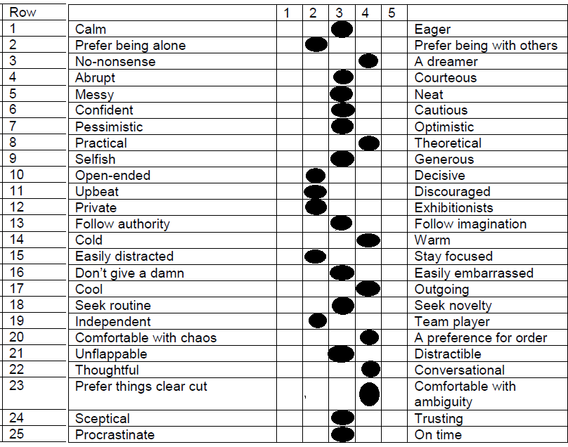

Annexure 2: Procrastination Indicator
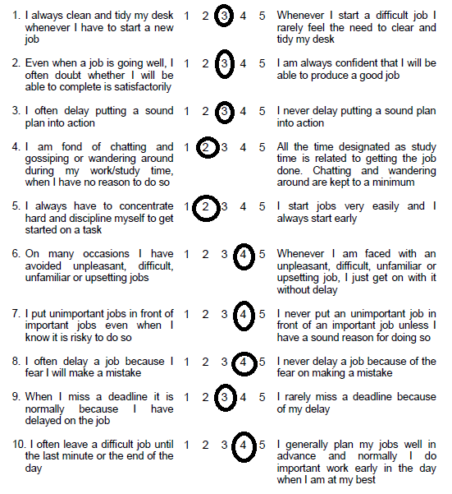

Annexure 3: Type A & B Personality
